|  |  |  |  |  |  |
| --- | --- | --- | --- | --- | --- |
| **Module No:** | 1 | **IU No:** | 2 | **Exercise No.** | 1 |

|  |  |
| --- | --- |
| **Lab Assessment Statement** | **Assignment 2 - Spring MVC**  **You are developing a "Know-Your-Neighborhood" application. The goal of this application is to provide details on all stores in the users neighborhood. For this to happen, the application should have a list of stores in the town. Hence, develop Entity, Controller, Service and DAO classes to add store to the system.**   1. **Create the Store Entity object with below fields.**    1. **String name**    2. **String phone_number**    3. **String[] localities // list of areas or localities the store serves** 2. **Develop a Controller class with a method to add Store to the system with POST HTTP method.  http://<host>:<port>/stores** 3. **Develop a Service class to add Store to the repository** 4. **Develop a DAO class that just adds given store to the list of stores maintained.**    1. **We didn’t go through the database module yet.**    2. **So just maintain a list of stores as a field (i.e., member variable) in DAO class.**    3. **Add a store object to that list.** |
| **Technical Environment** | - |
| **Guidelines** | - |
| **Duration** | 120 mins |

1. **Create the Store Entity object with below fields.**
   1. **String name**
   2. **String phone_number**
   3. **String localities // list of areas or localities the store serves**

**Store Model/Entity**

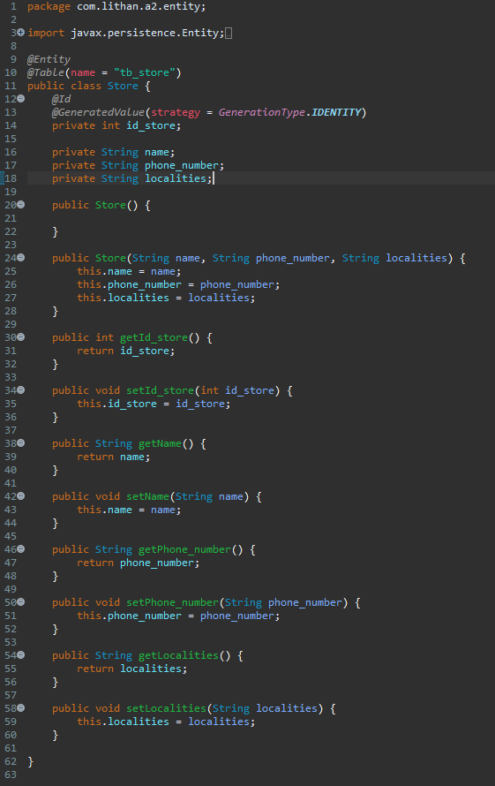

1. **Develop a Controller class with a method to add Store to the system with POST HTTP method.  
    http://<host>:<port>/stores**

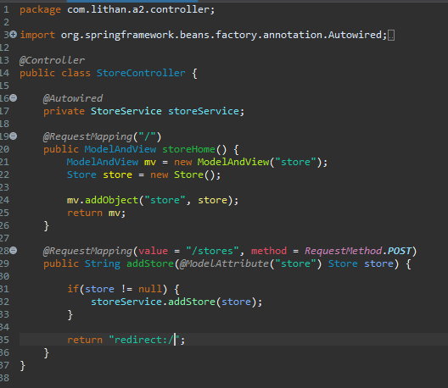

1. **Develop a Service class to add Store to the repository**

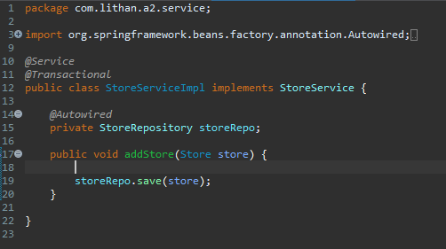

1. **Develop a DAO class that just adds given store to the list of stores maintained.**
   1. **We didn’t go through the database module yet.**
   2. **So just maintain a list of stores as a field (i.e., member variable) in DAO class.**
   3. **Add a store object to that list.**

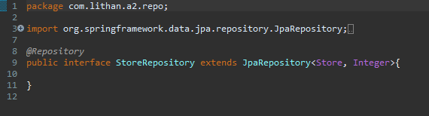

**Before Submit**

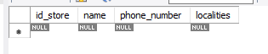

**After Submit**

